*Email Basics* is a two- to four-hour course designed to introduce you to email and other forms of electronic communication. You will learn how to register for an email account, navigate an email interface, compose, send and receive messages, manage a contact list, and upload and download attachments. The course will also provide a brief overview of safety concerns and social networking.

*Objectives:*

* Create an online email account
* Create a secure password
* Write, open, reply, send, and forward email messages
* Add contacts to a contact list
* Send and open attachments

## *What is Email?*

Email is a way to exchange digital messages via the internet. Because email is so easy and convenient to use, it has revolutionized the way people communicate. In 2011, there were over 3 billion email accounts! Here are some advantages that email has over conventional mail or “snail mail”:

By creating an email account you will be able to send and receive messages instantly, helping you stay connected with friends, family and the rest of the planet.

|  |  |
| --- | --- |
| **Email** | **Snail Mail** |
| Send messages instantly | Mail arrives after 2-3 days |
| Access anywhere | Fixed physical address |
| Free with internet connection | Cost of a stamp |

**Other Advantages**

* Other tools (calendar, contact list chat)

* Private (password protected)

* Access other parts of the web

* Send emails to large numbers of people at once

* More than just text: share pictures and other files

* Easy to organize (if you know the tricks)

## *Parts of an Email Address:*

Gary.Glassjaw@gmail.com

username at email provider

What happens if you don’t type in an email address correctly?

Desktop email vs. “**Webmail**.” List popular web email providers below:

***Email Etiquette and Safety.*** Take notes as your instructor discusses email etiquette and safety.

1. Sending Email

* Difference between Reply and Reply All

* Check addresses before sending

* Check email for typos before sending

* Don’t forward chain mail!

1. Personal Email To Friends And Family

* More informal

* Subject lines—relevant

Fonts and styles (don’t write in all caps or use lots of different fonts, hard to read colors)

* Greetings, closing lines (Hi ______, thanks, etc.)

* Feelings can be difficult to convey in an email. Use **emoticons** can help set the tone of email. See more on emoticons at the end of this student manual.

1. Business Email

* Appropriate email addresses to leave a good first impression

* Use a formal tone when applying for jobs; can use more relaxed but still professional tone in established business relationships

* Company may be able to read your emails.

1. Protecting Yourself

* Make your password difficult to guess and never tell anyone your password

* Spam—Junk mail that could harm your computer. Don’t open or reply to it! Show how to move to spam to spam folder

* Phishing—Scam that pretends to be an official communication from a trusted source, like a bank, trying to get valuable information from you. Do not give out your information if you are not sure.

* Only open attachments from people you trust

Beyond Email

* Calendar

* To-do list

* Email is the first step to using the internet to communicate. Now there are lots of other ways to connect with people over the internet:
* Social Networks—Facebook, LinkedIn, Twitter, Google Plus

* Internet Phone—make calls to anyone in the world through services like Skype.

There are **3** main email windows: **inbox, email message window, compose window**

1. **Inbox**: What are the main parts of the inbox?

1. **Email** **Message Window**: What are the main parts of the message window?

1. **Compose Message Window**: What are the main parts of the compose message window?

**Key Email Functions.**You will practice the following key email functions hands-on with your instructor using instructions in the Student Manual.

*3.0.2 Create an Email Account*

*3.0.3 Writing and Sending an Email*

*3.0.4 Reading and Replying to an Email*

*3.0.5 Forwarding an Email*

*3.0.6 Sending an Attachment*

*3.0.7 Opening an attachment*

*3.0.8 Adding Contacts*

*3.0.9 Signing In and Out of Your Email*

***3.0.2 Create an Email Account***

There are several different options for email providers. Some of the more popular providers are Gmail and Yahoo. Here is how you sign up for a Google account:

1. 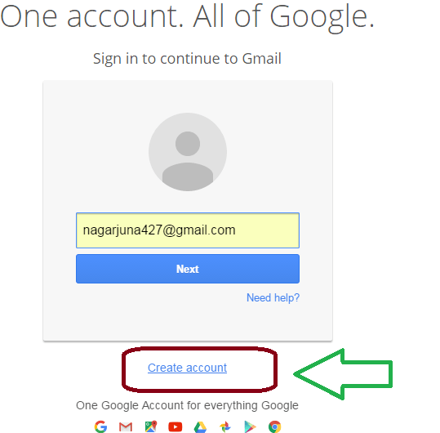In your web browser, go to Gmail.com
2. Click the “Create account” button at the bottom.
3. Fill out the required information including your name, username, password, and a few other things.
4. Use the Google Email Cheat Sheet below to help you.
5. Write your email address and your password here:

My Email Address: _____________________@ google.com

My Email Password: ____________________

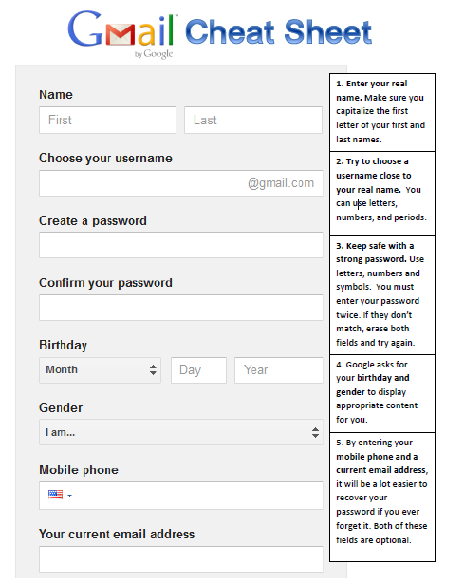***3.0.3 Writing and Sending an Email***

1. Get an email address from another student. Write it here:

Partner 1’s Address: ___________________________

1. From the Inbox, click on **Compose Message**. This will take you to a new window where you can write your email.
2. 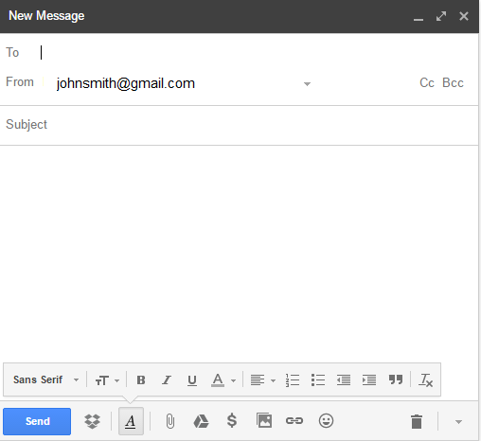In the **To** line, type the email address of your partner exactly as written above.
3. In the **Subject** line, write “My First Email.”
4. Click in the big white box below the “Subject” line. This is the **body** of the message.
5. Write a **greeting** (Hello, Hey, Hi, etc.)
6. Write three questions for your partner such as  
   *What is your favorite color? What month is your birthday? Where were you born?*
7. Include a **closing** at the end (Thanks, Sincerely, Bye)
8. Click the **Send** button. Congratulations, you just sent your first email!

***3.0.4 Reading and Replying to an Email***

From your inbox, click the new email you received from your partner. This opens up the **Read Message window.**

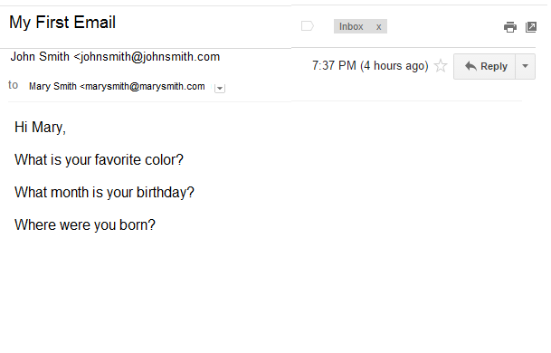

1. 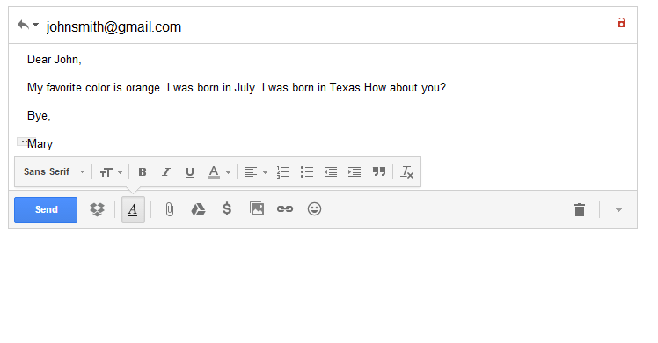Click the **Reply** button. This opens up a new email.
2. Answer your partner’s questions. Remember to include a greeting and closing.
3. Click **Send**

***3.0.5 Forwarding an Email***

If you ever receive an email that you would like to share, you can easily send it to someone else using the forward link.

1. Find a new partner and get their email address. Write it here:

Partner 2’s Email Address: ______________________________________

1. Now re-open the email you received from your original partner. This time click the   
   **Forward** button. In Gmail, you have to use the Drop Down menu under the Reply button.

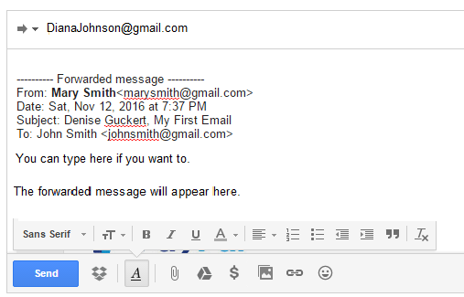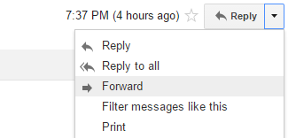

1. Carefully enter Partner 2’s email address.
2. If you’d like, you can write something in the body.
3. Click **Send**. You’re done!

***3.0.6 Sending an Attachment***

1. Create an email to a classmate and click on the paperclip symbol.
2. 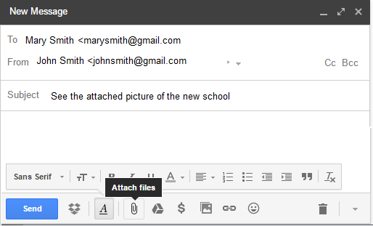Navigate to the file you want to attach and click on it. Choose any file.

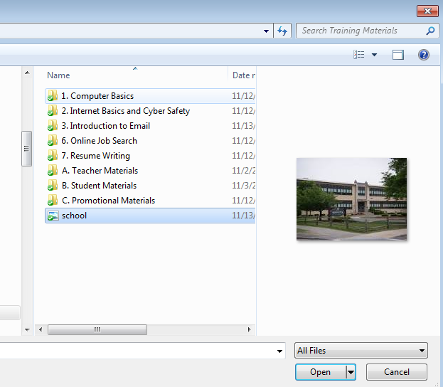

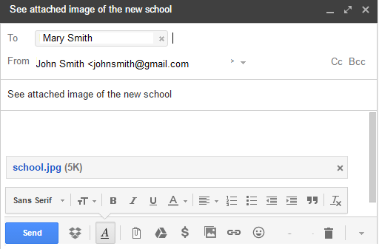

1. The attachment appears at the bottom of the email.
2. Click Send.

***3.0.7 Opening an attachment***

1. Open the message that has an attachment that your classmate sent you. Notice the paperclip attachment symbol.

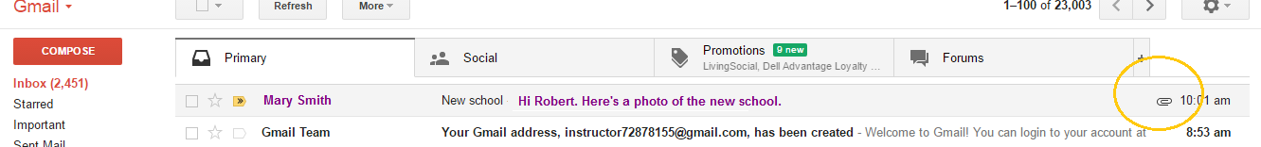

1. 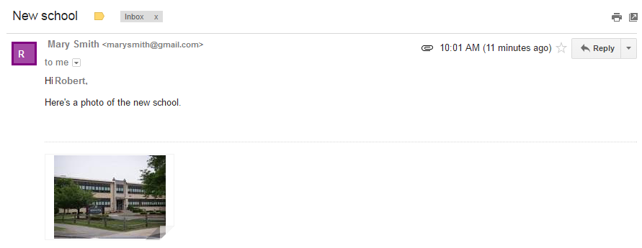Open the email message. You can preview the attachment in the window.
2. If you are certain that you know the person sending the email and that the attachment is SAFE, then click on it to download or open it on your computer.

***3.0.8 Adding Contacts***

A contact list is an address book where you can keep the names and email addresses of people you communicate with. By creating a contact list, you won’t have to remember the exact spelling of other people’s email addresses. Here are two ways to add contacts to your list in Gmail:

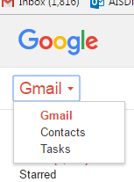

Method 1

1. In Gmail, go the left top of the page to the Gmail dropdown. Click on Contacts.
2. 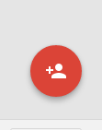The Add New Contact button is way to the right bottom of the screen.
3. Type in the name of the person.
4. Now type in information about the person. You only need to add the email address but you can add phone numbers, photos, and much more.
5. Click the **Save** button. Now when you write an email to someone on your contact list, you only need to type in the first few letters of their name in the **To** line and their name will pop up automatically.

Method 2

1. 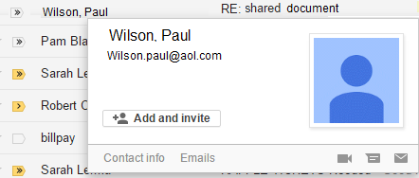In Gmail, if you receive an email from someone you want to add to your contact list, you only need to hover your mouse over the person’s name for a contact box to pop up. You can click on the plus sign to add the person and their email to your contact list.

***3.0.9 Signing In and Out of Your Email***

It’s important that you always sign out after you finish your email session. Otherwise, the next person to use the computer may have access to your personal information. Think of it like locking the door after you leave your house.

1. At the very top of the page look for the profile icon. It could be blank or if you added a photo, it will look like the photo:
2. 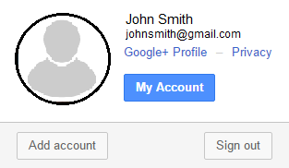A box will pop up with the option to Sign Out.

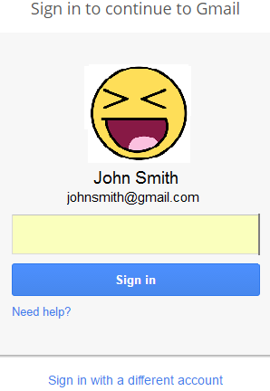

1. To sign back into your email account, go to gmail.com or google.com.
2. If you do not see YOUR name and email, then choose the “Sign in with a different account” link at the bottom.

**Advanced Email Information**

1. **Sending an email to multiple recipients**: Put one address in the **To** line and another in the **CC** (carbon copy) line. If you want to hide the identities of your recipients from each other, use **BCC** (blind carbon copy).
2. **Formatting your email**: Test the different tools on the format bar such as **font, size, style, color, alignment.**
3. **Emoticons**: An emotion is a way to show your feelings in an email. Click the E**moticon** button to choose from a face that represents the tone of your email. You can also type emotions on the keyboard. Some common emoticons:

|  |  |
| --- | --- |
| Happy | :) |
| Sad | :( |
| Wink | ;) |
| Big Smile | :D |
| Tongue | :P |
| Angry | X( |

1. **Attachments**: Send music, pictures, documents, or any other type file as an attachment. Click the **Attachment** button. Go to the student folder and choose a picture to send as an attachment.
2. **Organize email with folders**: You may want to organize your email to make it easier to find something important later. Select a message by checking the box on the left side of the inbox panel. Then click the **Folder** icon. From the menu, select **New Folder.** Create a name for the new folder like “Email 101.” Your new folder will appear on the left panel. See what’s inside by clicking it. Additionally, you can use click the **star** icon to mark an email as important.
3. **Trash and Spam**: If you want to get rid of an email, select it and click the folder icon again. To delete the email, choose the **Trash** option. After some time, you will likely receive junk email called **spam.** Most email providers have spam filters built in, but if you receive a spam email, you should move it to the **spam folder** instead of the trash. This teaches the spam filter to recognize junk mail in the future.
4. **Search old email**: If you want to find a particular email, you can type a few keywords in the **search bar** and press “enter” to see all emails containing your search terms.
5. **Customize Your Account:** Click the **Options** menu and choose **Mail Options.** Here you can set up your account preferences, create a signature, program email filters, and a lot more.

***Email Terminology***

Attachment: an uploaded file (picture, song, document, etc.) sent over email.

BCC: short for “blind carbon copy.” Adding email addresses to the BCC line of an email is a way to email multiple recipients without revealing their email addresses to other recipients. This is good idea if you want to protect the privacy of your contacts.

CC: short for “carbon copy.” Adding email addresses to the CC line of an email is a way to send a copy of an email to someone who is not the main recipient. Use CC to keep people informed of topics they may have an interest in.

Contact List: a list of people you communicate with over email. Contact lists can include names, email addresses, phone numbers, physical addresses, usernames, and more.

Draft: an unfinished and unsent email. A draft is saved in the draft folder.

Email: a way to exchange electronic messages over the internet.

Email Address: identifies where email is sent. Every email address has three parts: username, @ symbol, and a domain name (i.e. gmail.com).

Emoticon: a small icon, usually a face, representing an email writer’s emotion. Emoticons are often used to casually set the tone of a message.

Filter: a way to automatically organize email according to rules set by the email user.

Folder/Label: used to organize emails by user-specified category.

Forward: send a copy of an existing message to a new recipient. Abbreviated as “FW.”

Inbox: place where messages are received. Unread messages are usually displayed in bold.

Instant Message: also called “chatting,” this is an informal way to send short messages and receive immediate responses, allowing users to have real-time conversations.

Phishing: an email-based scam that attempts to gain users’ personal information by sending counterfeit messages that appear to be from a trusted entity like a bank. Email users should always be wary when they receive messages asking for personal information like passwords, bank account numbers, social security numbers, and so on. See spam below.

Reply: respond to a received message. Abbreviated as “RE.”

Reply All: respond to all recipients of a message. Be careful when replying to multiple recipients!

Sign in/Sign out: securely enter and leave email account. Sometimes called “log on/log off.”

Spam: junk mail sent over email. Some spam contains viruses that could harm your computer, so never open email from an unknown sender. Many email programs use spam filters that try to keep spam out of the inbox.

Subject: descriptive text that explains the purpose of a message.

Webmail: a web-based email service accessed via a web browser, like Internet Explorer. Webmail can be accessed anywhere with an internet connection. Examples of webmail are Gmail and Yahoo mail.

## *Emoticons*

:-) ☺ Smile

^-^ Delighted

:-D Big Toothy Smile

:-X Lips are sealed

;-) Wink

:-( ☹ Frown

:-/ Sarcasm

:-* Kiss

:-O Scream or Surprise

-_- Disappointed, Upset, Ashamed

There are many more emoticons in use than the ones listed above. If you search for the term emoticon, you will literally receive millions of results ☺

## *Text, Chat and Email Acronyms / Abbreviations*

[tmw](http://www.netlingo.com/word/2moro.php) - Tomorrow

[2nite](http://www.netlingo.com/word/2nite.php) - Tonight

[BRB](http://www.netlingo.com/word/brb.php) - Be Right Back

[BTW](http://www.netlingo.com/word/btw.php) - By The Way

[B4N](http://www.netlingo.com/word/b4n.php) - Bye For Now

[BFF](http://www.netlingo.com/word/bff.php) - Best Friends Forever

[CYA](http://www.netlingo.com/word/cya.php) - See Ya

[FWIW](http://www.netlingo.com/word/fwiw.php) - For What It's Worth

[GR8](http://www.netlingo.com/word/gr8.php) - Great

[IMHO](http://www.netlingo.com/word/imho.php) - In My Humble Opinion

[J/K](http://www.netlingo.com/word/jk.php) - Just Kidding

[L8R](http://www.netlingo.com/word/l8r.php) - Later

[LYLAS](http://www.netlingo.com/word/lylas.php) - Love You Like A Sister

[NIMBY](http://www.netlingo.com/word/nimby.php) - Not In My Back Yard

[NOOB](http://www.netlingo.com/word/nub.php) - New person to a site or game

[OMG](http://www.netlingo.com/word/omg.php) - Oh My God

[POV](http://www.netlingo.com/word/pov.php) - Point Of View

[ROTFL](http://www.netlingo.com/word/rotflmao.php) - Rolling On The Floor Laughing

[THX or](http://www.netlingo.com/word/thx-or-tx-or-thks.php)  TX - Thanks

[TMI](http://www.netlingo.com/word/tmi.php) - Too Much Information

[TTYL](http://www.netlingo.com/word/ttyl.php) - Talk To You Later -or- Type To You Later

[XOXO](http://www.netlingo.com/word/xoxo.php) - Hugs and Kisses

[LOL](http://www.netlingo.com/word/lol.php) - Laughing Out Loud -or- Lots Of Love

There are many more acronyms / abbreviations in use than the ones listed above, and new ones are being incorporated into popular use all of the time. If you want to stay current, you can search for “text abbreviations” or “text acronyms.”